1:write program to test Hello World.

Program:

#include<iostream>

using namespace std;

int main(){

cout<<"hello world";

}  
Output:

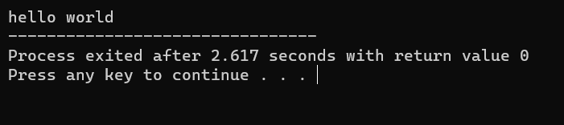

2:Write a program to adddition of two numbers .

Program:

#include<iostream>

using namespace std;

int main(){

int a,b;

cout<<"enter two value";

cin>>a>>b;

cout<<"addition is "<<a+b;

}  
Output:

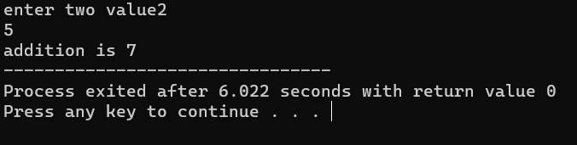

3:Write a program to swap two numbers.

Program:

#include<iostream>

using namespace std;

int main(){

int a,b,c;

cout<<"enter two value";

cin>>a>>b;

c=a;

a=b;

b=c;

cout<<"after swapping "<<a<<" "<<b;

}

Output:

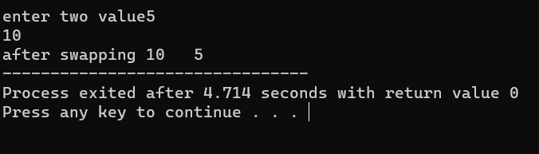

4. Write a program to accept an integer and check if it is even or odd.

Program:

#include<iostream>

using namespace std;

int main()

{

int n;

cout<<"enter the number ";

cin>>n;

if(n%2==0){

cout<<"given number is even ";

}

else{

cout<<"given number is odd ";

}

}  
Output:

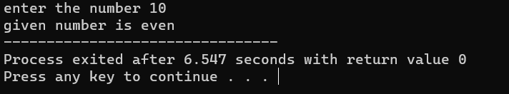

5. Write a program to accept a number and check if it is divisible by 5 and 7.

Program:

#include<iostream>

using namespace std;

int main()

{

int n;

cout<<"enter the number ";

cin>>n;

if(n%5==0 && n%7==0 ){

cout<<"number is idivisible by 5 and 7 ";

}

else{

cout<<"number is not divisible by either 5 &7 or both";

}

}  
Output:

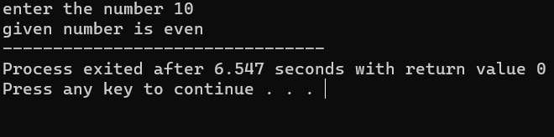

6. Write a program, which accepts annual basic salary of an employee and calculates and displays the

Income tax as per the following rules.

Basic: < 1, 50,000 Tax = 0

1, 50,000 to 3,00,000 Tax = 20%

> 3,00,000 Tax = 30%

Program:

#include<iostream>

using namespace std;

int main()

{

int bs,tax;

cout<<"enter basic salary of employee: ";

cin>>bs;

if(bs<50000){

cout<<"tax is 0";

}

else if(bs>50000 && bs<300000){

tax=(bs\*20)/100;

cout<<"tax is "<<tax;

}

else{

tax=(bs\*30)/100;

cout<<"tax is"<<tax;

}

}  
Output:

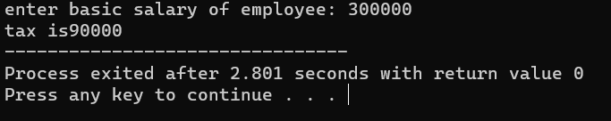

7. Accept a lowercase character from the user and check whether the character is a vowel or consonant.

(Hint: a, e, i, o, u are vowels)

Program:

#include<iostream>

using namespace std;

int main()

{

char c,x;

do{

cout<<"enter the character"<<endl;

cin>>c;

if(c=='a'||c=='e'||c=='i'||c=='o'||c=='u')

{

cout<<"you entered vowels"<<endl;

}

else{

cout<<"you entered consenant \n";

}

cout<<"want to continue y/n \n";

cin>>x;

}

while(x!='n');

}  
Output:

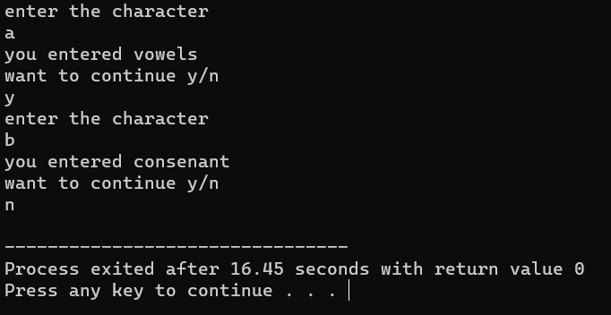

8. Write a program to input angles of a triangle and check whether triangle is valid or not.

Program:

#include<iostream>

using namespace std;

int main()

{

int first,second,third;

cout<<"enter the angles of triangle ";

cin>>first>>second>>third;

if(first+second+third==180){

cout<<"triangle is valid ";

}

else{

cout<<"triangle is invalid ";

}

}  
Output:

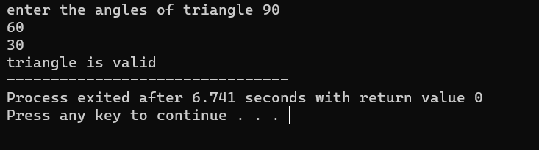

9:Write a program to find factorial of a given number. ex:no5 fact=5\*4\*3\*2\*1=120

Program:

#include<iostream>

using namespace std;

int main()

{

int i,n,res=1;

cout<<"enter the number to find factorial";

cin>>n;

for(i=1;i<=n;i++)

{

res=res\*i;

}

cout<<"factorial of "<<n<<" is :"<<res;

}  
Output:

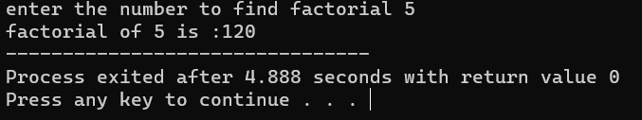

10:Write a program to find m to the power n. m=3 and n=4 so 3\*3\*3\*3

Program:

#include<iostream>

using namespace std;

int main(){

int n,pow,res=1;

cout<<"enter the number";

cin>>n;

cout<<"enter the power";

cin>>pow;

for(int i=1;i<=pow;i++)

{

res=res\*n;

}

cout<<"answer is"<<res;

}  
Output:

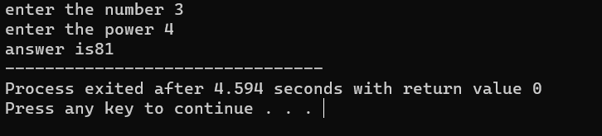

11:Check if number is a prime number or not.:

Program:

#include<iostream>

using namespace std;

int main(){

int n,i;

bool flag=true;

cout<<"enter the number \n";

cin>>n;

for (i=2;i<n;i++){

if(n%i==0){

flag=false;

break;

}

}

if (flag==false){

cout<<"number is not prime";

}

else{

cout<<"number is prime";

}

}  
Output:

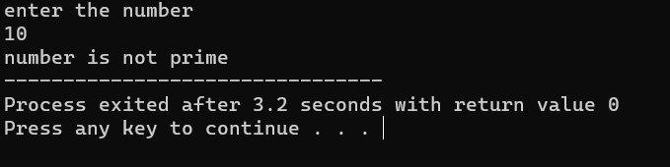

12:Sum of series :

1+2+3+….+n

Program:

#include<iostream>

using namespace std;

int main()

{

int n,sum;

cout<<"enter the number ";

cin>>n;

for(int i=1;i<=n;i++)

{

sum=sum+i;

}

cout<<"sum up to "<<n<<"number is "<<sum;

}  
Output:

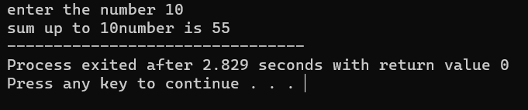

13:Check whether the number is palindrome or not?

Program:

#include<iostream>

using namespace std;

int main()

{

int n,rev,d,temp;

cout<<"enter the number ";

cin>>n;

temp=n;

do{

d=temp%10;

rev=rev\*10+d;

temp=temp/10;

// cout<<" temp is "<<temp<<" rev is "<<rev;

}while(temp!=0);

if(rev==n){

cout<<"number is palindrome";

}

else

{

cout<<"number is not palindrome";

}

}  
Output:

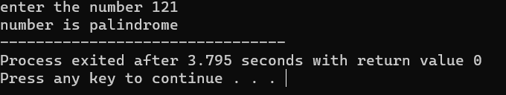

14:Write a program to find sum of all even and odd numbers between 1 to n.

Program:

#include<iostream>

using namespace std;

int main()

{

int odd,even,n,sumOdd=0,sumEven=0;

cout<<"enter the number ";

cin>>n;

for (int i=0;i<=n;i++)

{

if(i%2==0)

{

sumEven=sumEven+i;

}

else{

sumOdd=sumOdd+i;

}}

cout<<"sum of odd number in range 1 to "<<n<<"is "<<sumOdd<<endl;

cout<<"sum of even number in range 1 to "<<n<<"is "<<sumEven<<endl;

}  
Output:

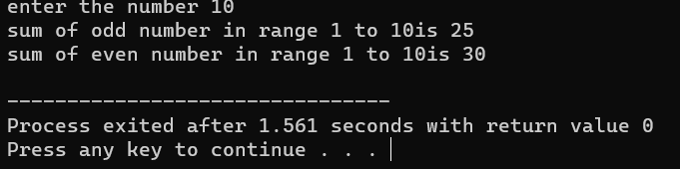

15: Write a program to enter a number and print its reverse.

Program:

#include<iostream>

using namespace std;

int main()

{

int n,rev,i,digit,temp;

cout<<"enter the number: "<<endl;

cin>>n;

temp=n;

while(temp!=0){

digit=temp%10;

rev=rev\*10+digit;

temp=temp/10;

}

cout<<"reverse of "<<n<<"is "<<rev;

}  
Output:

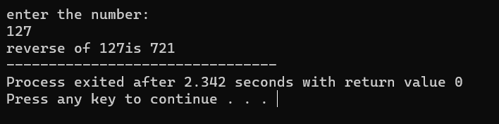

16:Write a program to print all Prime numbers between 1 to n.

Program:

#include<iostream>

using namespace std;

int main()

{

int i,n;

cout<<"enter the number "<<endl;

cin>>n;

for (i=1;i<=n;i++)

{

bool flag=true;

if(i==0 ||i==1)

{

continue;

}

else{

for(int j=2;j<i;j++)

{

if(i%j==0)

flag=false;

}

if(flag==true)

{

cout<<i<<" ";

}

}}

}  
Output:

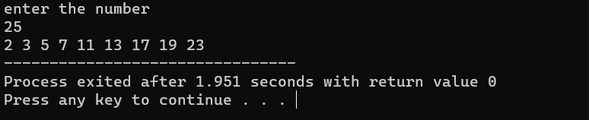

17:Write a program to check entered number is Armstrong number or not.

Program:

#include<iostream>

using namespace std;

int main()

{

int n,digit,sum=0,i;

cout<<"enter the number"<<endl;

cin>>n;

int num=n;

while(num!=0)

{

digit=num%10;

sum=sum+(digit\*digit\*digit);

num=num/10;

}

if(sum==n){

cout<<"given number is armstrong"<<endl;

}

else

cout<<"given number is not armstrong";

}  
Output:

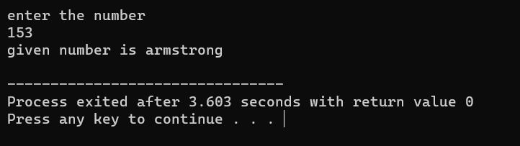

18:Write a program to find greatest of three numbers using nested if-else.

Program:

#include<iostream>

using namespace std;

int main()

{

int a,b,c;

cout<<"enter three numbers"<<endl;

cin>>a>>b>>c;

if(a>b)

{

if(a>c)

{

cout<<a<<" is greater"<<endl;

}

else

cout<<c<<" is greater"<<endl;

}

else

{

if(b>c)

{

cout<<b<<" is greater"<<endl;

}

else

cout<<c<<" is greater"<<endl;

}

}  
Output:

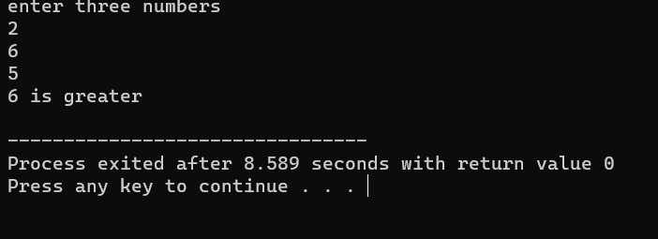

19:Create menu driven program for Pizza Shop. And display total amount,

Program:

#include<iostream>

using namespace std;

int main()

{

int qnt,n,i,ch,total;

cout<<"1.veg pizza 80 2.non-veg pizza 150 3.onion pizza 100 4.exit"<<endl;

do

{

cout<<"enter the choice"<<endl;

cin>>ch;

switch(ch)

{

case 1:

cout<<"enter quantity"<<endl;

cin>>qnt;

total=total+qnt\*80;

break;

case 2:

cout<<"enter quantity"<<endl;

cin>>qnt;

total=total+qnt\*150;

break;

case 3:

cout<<"enter quantity"<<endl;

cin>>qnt;

total=total+qnt\*100;

break;

case 4:

cout<<"exit"<<endl;

break;

default:

cout<<"please enter valid choice"<<endl;

}

}while(ch!=4);

cout<<"total bill is "<<total<<endl;

}  
Output:

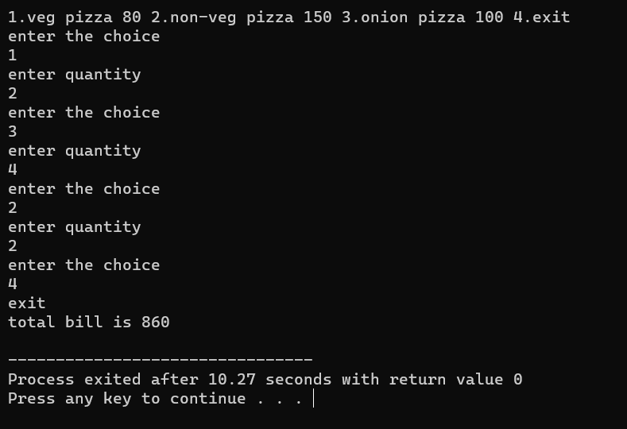

20:Accept a single digit from the user and display it in words. For example, if digit entered is 9,

Program:

#include<iostream>

using namespace std;

int main()

{

int n,ch;

cout<<"enter the number"<<endl;

do

{

cin>>ch;

switch(ch)

{

case 1:

cout<<"one"<<endl;

break;

case 2:

cout<<"two"<<endl;

break;

case 3:

cout<<"three"<<endl;

break;

case 4:

cout<<"four"<<endl;

break;

case 5:

cout<<"five"<<endl;

break;

case 6:

cout<<"six"<<endl;

break;

case 7:

cout<<"seven"<<endl;

break;

case 8:

cout<<"eight"<<endl;

break;

case 9:

cout<<"nine"<<endl;

break;

// case 0:

// cout<<"zero"<<endl;

// break;

default:

cout<<"invalid choice"<<endl;

}

}while(ch!=10);

return 0;

}  
Output:

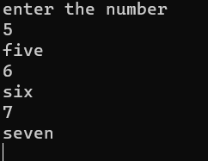

display Nine.

21. Write a program, which accepts two integers and an operator as a character (+ - \* / ), performs the

corresponding operation and displays the result.

Program:

#include<iostream>

using namespace std;

int main()

{

int n,ch,b,a;

do

{

cout<<"enter the number "<<endl;

cin>>a>>b;

cout<<"enter the choice \n 1.add 2.sub 3.mul 4.div 5.exit"<<endl;

cin>>ch;

switch(ch)

{

case 1:

cout<<a+b<<endl;

break;

case 2:

cout<<a-b<<endl;

break;

case 3:

cout<<a\*b<<endl;

break;

case 4:

cout<<a/b<<endl;

break;

case 5:

cout<<"Thank You!"<<endl;

break;

default:

cout<<"invalid choice"<<endl;

}

}while(ch!=5);

return 0;

}  
Output:

